**Do you require the hub site to have 1 physical port(UNI 100gb access) with 6 logical ports (EVC's) or do you need to have 6 physical ports at the Hub to connect to the remotes?**

**Answer:**

Question: Do you require the hub site to have 1 physical port(UNI 100gb access) with 6 logical ports (EVC's) or do you need to have 6 physical ports at the Hub to connect to the remotes?

We were not certain how to appropriately answer the question. We have attached a diagram to provide a clearer explanation of our current situation:

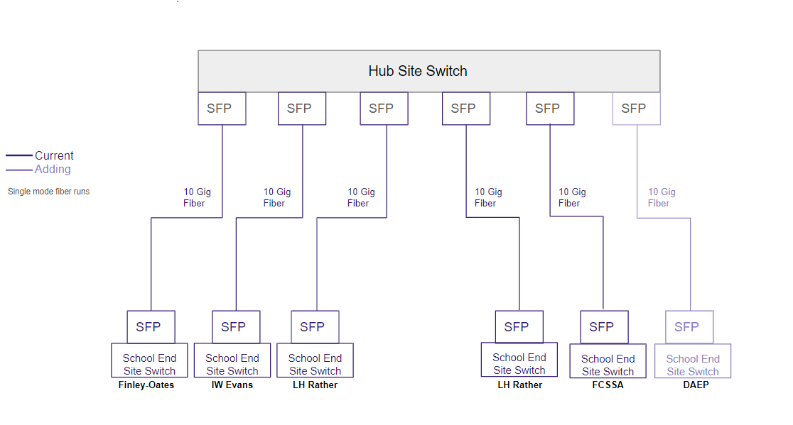

**How are these sites currently connected? Fiber? Lit or Dark?**

**Answer:**

**Question:** How are these sites currently connected? Fiber? Lit or Dark?

They are currently connected with dark fiber and a vendor-supplied GBIC.